IQX Web Referencing User Guide
V1.01
Gareth Johnstone and Ivan Baldwin



Web Referencing User Guide
Users can now send reference requests and receive references from within IQX via the web. Referees will be able to log onto a temporary website to complete the reference which will automatically update the IQX database. This functionality requires System Administrator set up in addition to the existence of IQXWeb/Hub.

Using Web Referencing
Open the record of the candidate whom you need a reference for. Select Web Reference – New Reference.
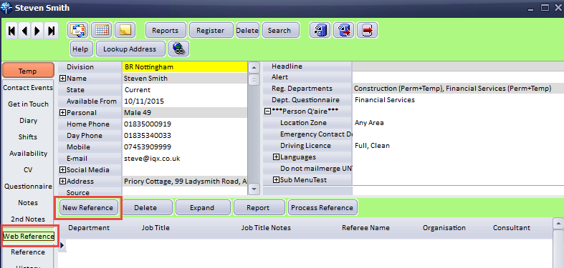
Complete the reference details in the next window. Save and close.
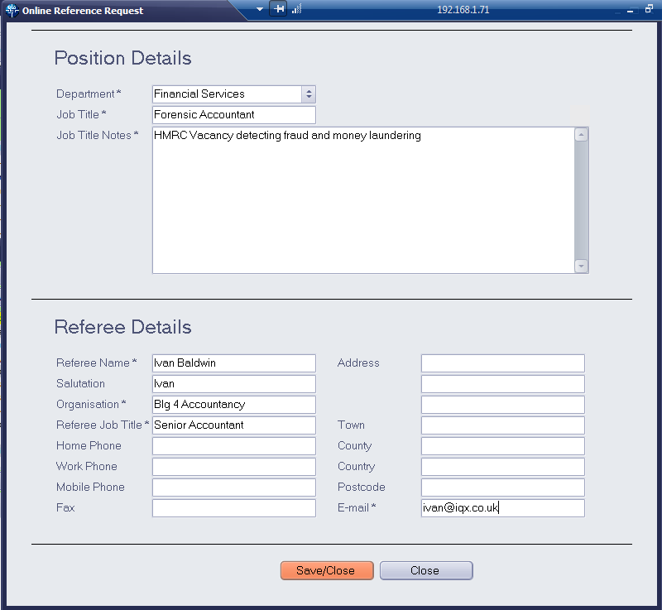
On returning to the Person Record the new reference will be recorded with a green font. This indicates the reference has been created but not sent yet.
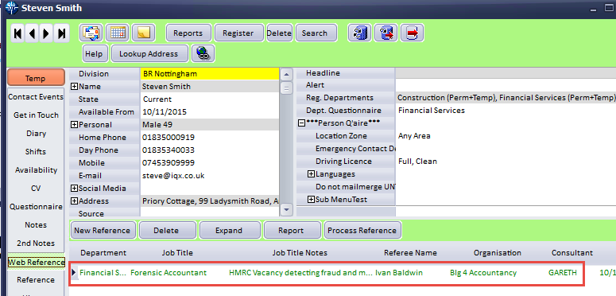
Reference requests to referees will be sent out periodically as set up by your System Administrator.
Below is an example of the email a referee will receive. To complete the reference they will need to click ‘Click here to access your reference’. The text of the letter can be set up using Boiler Plate text and is accessed through our Branding feature.
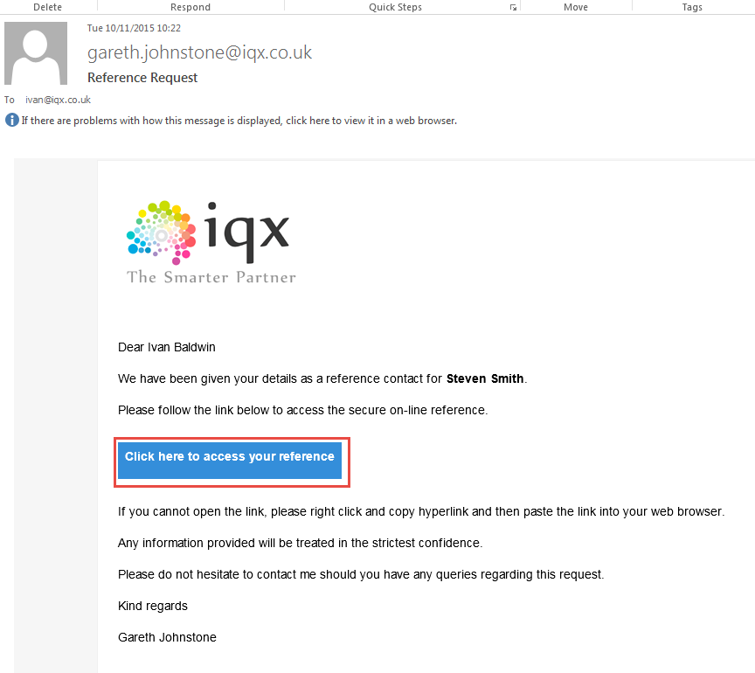
On clicking this button they will be taken to a temporary website containing the reference questions.
Referees can complete the reference in one sitting then click Save and Send or they can Save the reference and return to complete it at a later date. Note – the website is only available for 7 days.
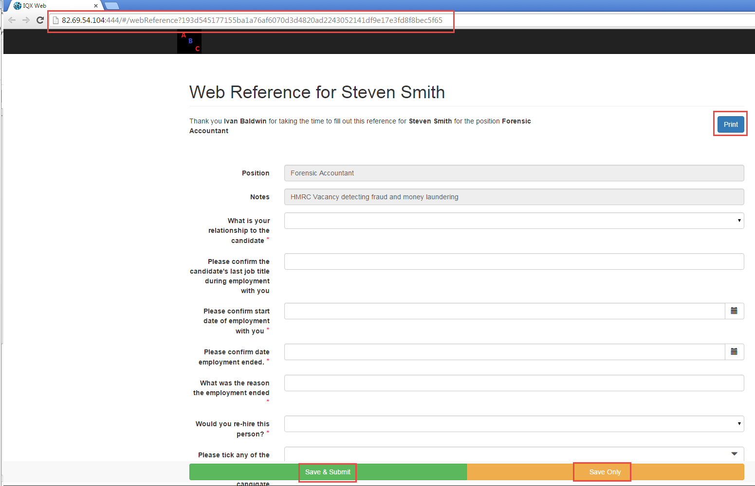
Once the reference has been completed The Web Reference record will change font colour to black
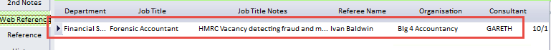
Double clicking on the Web Reference record will open it. It will show the referee’s response along with some audit information.
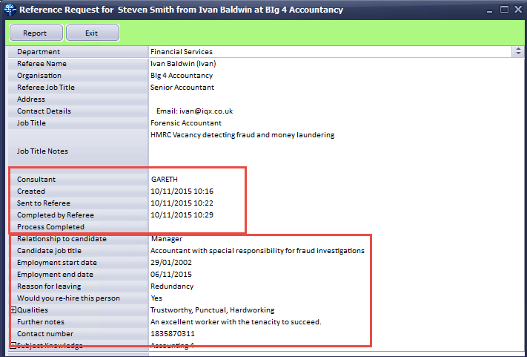
To send a summary of the referee’s response, if required, is also an automatic job.
Below is an example of the email the referee will receive.
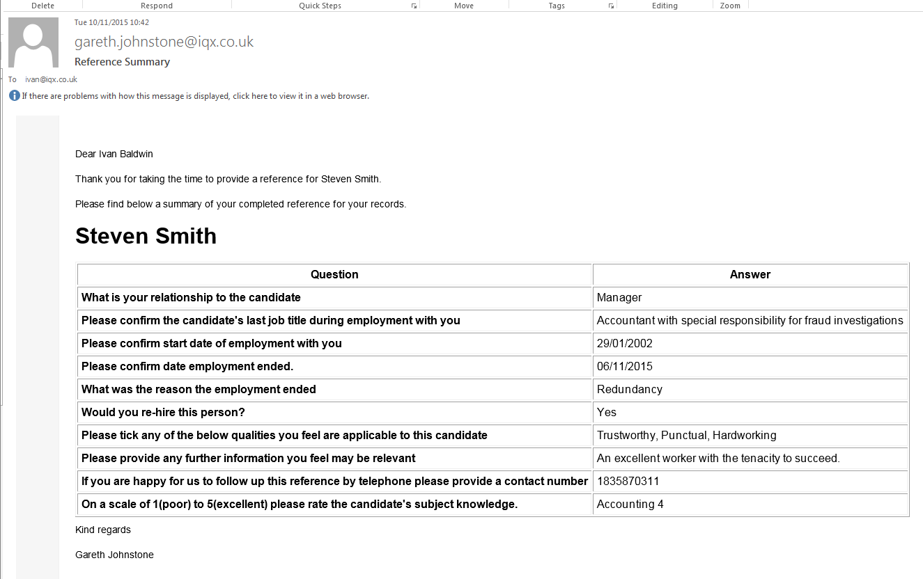
Once the reference has been reviewed and a summary sent (if required) click ‘Process Reference’ to indicate you have viewed the data. This will turn the Web Reference record blue.
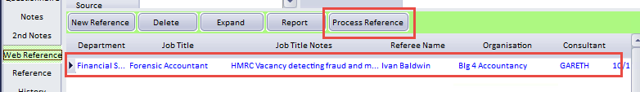
The date and time the reference was processed will be added to the web reference. See below.
