IQX Web Referencing Setup Guide
V1.01
Gareth Johnstone and Ivan Baldwin


Table of Contents
What you need to run it 3
IQX Database Update 3
SQL for the database table 3
Woodpecker File Update. 6
Job for WoodPecker 6
System Administrator Setup 12
IQXNet Setup 12
Switchable Views Setup 13
Setting up Branding 13
Reference Questionnaire Setup 15
Job Runner Scheduling 16
Web Reference – Sending out the reference requests 17
Reference Request Job - Send Web Reference Emails.xml 17
The Summary – Send Web Reference Summary.xml. 22

What you need to run it
- A version of IQX with Branding 2.3.5.7 onwards.
- IQXHub (latest) and associated IQXWeb functionality
- nodeJS
IQX will set up IQX Hub and IQXWeb along with associated database and wpk changes. This will be a chargeable item.

IQX Database Update
This information is provided for information purposes only. Changes to the database should only be carried out by experienced personnel. Before any changes ensure a backup of the database has been made.
Table ReferenceRequest should already be in the database. However, if the table is incomplete it should be deleted and the following SQL run to recreate the table.

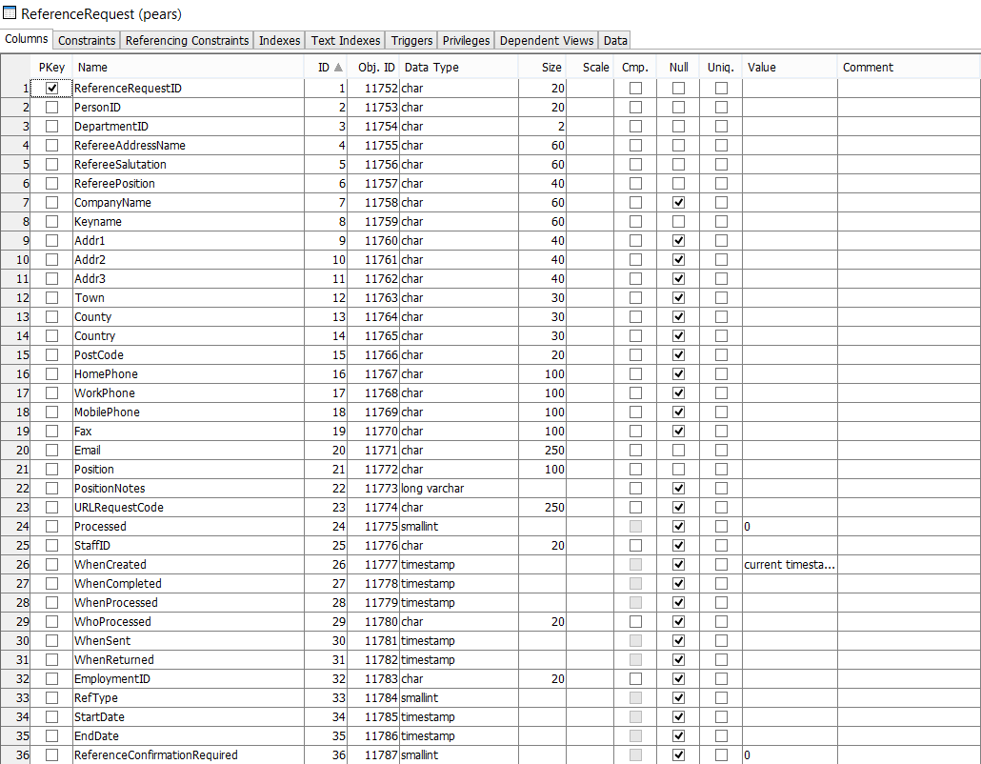

SQL for the database table
Copy and paste this SQL into SQL Tool in the IQX program.
CREATE TABLE "pears"."ReferenceRequest" (
"ReferenceRequestID" CHAR(20) NOT NULL,
"PersonID" CHAR(20) NOT NULL,
"DepartmentID" CHAR(2) NOT NULL,
"RefereeAddressName" CHAR(60) NOT NULL,
"RefereeSalutation" CHAR(60) NOT NULL,
"RefereePosition" CHAR(40) NOT NULL,
"CompanyName" CHAR(60) NULL,
"Keyname" CHAR(60) NOT NULL,
"Addr1" CHAR(40) NULL,
"Addr2" CHAR(40) NULL,
"Addr3" CHAR(40) NULL,
"Town" CHAR(30) NULL,
"County" CHAR(30) NULL,
"Country" CHAR(30) NULL,
"PostCode" CHAR(20) NULL,
"HomePhone" CHAR(100) NULL,
"WorkPhone" CHAR(100) NULL,
"MobilePhone" CHAR(100) NULL,
"Fax" CHAR(100) NULL,
"Email" CHAR(250) NOT NULL,
"Position" CHAR(100) NOT NULL,
"PositionNotes" LONG VARCHAR NULL,
"URLRequestCode" CHAR(250) NULL,
"Processed" SMALLINT NULL DEFAULT 0,
"StaffID" CHAR(20) NULL,
"WhenCreated" TIMESTAMP NULL DEFAULT CURRENT TIMESTAMP,
"WhenCompleted" TIMESTAMP NULL,
"WhenProcessed" TIMESTAMP NULL,
"WhoProcessed" CHAR(20) NULL,
"WhenSent" TIMESTAMP NULL,
"WhenReturned" TIMESTAMP NULL,
"EmploymentID" CHAR(20) NULL,
"RefType" SMALLINT NULL,
"StartDate" TIMESTAMP NULL,
"EndDate" TIMESTAMP NULL,
"ReferenceConfirmationRequired" SMALLINT DEFAULT 0,
PRIMARY KEY ( "ReferenceRequestID" ASC )
) IN "system";
ALTER TABLE "pears"."ReferenceRequest" ADD CONSTRAINT "Person" NOT NULL FOREIGN KEY ( "PersonID" ASC ) REFERENCES "pears"."Person" ( "personid" );
ALTER TABLE "pears"."ReferenceRequest" ADD CONSTRAINT "Department" NOT NULL FOREIGN KEY ( "DepartmentID" ASC ) REFERENCES "pears"."Department" ( "departmentid" );
ALTER TABLE "pears"."ReferenceRequest" ADD CONSTRAINT "staff" NOT NULL FOREIGN KEY ( "StaffID" ASC ) REFERENCES "pears"."staff" ( "staffid" );

Woodpecker File Update.
This information is provided for information purposes only. Changes to the woodpecker file should only be carried out by experienced personnel.
A new form is required in Woodpecker. Run the following Xml in WPKMaintain.exe to set up this form.
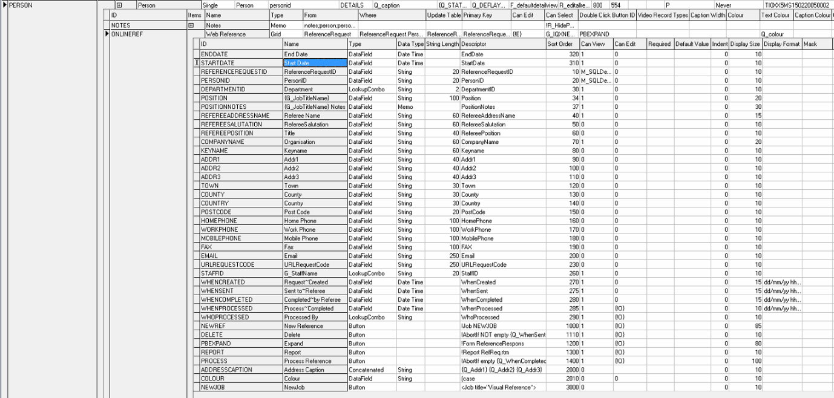

Job for WoodPecker
<Job title="Visual Reference">
<Parameters>
<Parameter name="cPersonID" type="String"/>
</Parameters>
<SetVariable name="xButton1caption" value="Save/Continue"></SetVariable>
<SetVariable name="xButton2caption" value="Save/Close"></SetVariable>
<SetVariable name="xButton1show" value="0"></SetVariable>
<SetVariable name="xButton2show" value="1"></SetVariable>
<SetVariable name="xShowSalutation" value="1"></SetVariable>
<SetVariable name="xShowKeyname" value="1"></SetVariable>
<SetVariable name="xRefereeAddressName" value=""></SetVariable>
<SetVariable name="xRefereeSalutation" value=""></SetVariable>
<SetVariable name="xKeyName" value=""></SetVariable>
<SetVariable name="xCompanyName" value=""></SetVariable>
<SetVariable name="xRefereePosition" value=""></SetVariable>
<SetVariable name="xHomePhone" value=""></SetVariable>
<SetVariable name="xWorkPhone" value=""></SetVariable>
<SetVariable name="xMobilePhone" value=""></SetVariable>
<SetVariable name="xFax" value=""></SetVariable>
<SetVariable name="xAddr1" value=""></SetVariable>
<SetVariable name="xAddr2" value=""></SetVariable>
<SetVariable name="xAddr3" value=""></SetVariable>
<SetVariable name="xTown" value=""></SetVariable>
<SetVariable name="xCounty" value=""></SetVariable>
<SetVariable name="xCountry" value=""></SetVariable>
<SetVariable name="xPostCode" value=""></SetVariable>
<SetVariable name="xEmail" value=""></SetVariable>
<SetVariable name="xStartDate" value=""></SetVariable>
<SetVariable name="xEndDate" value=""></SetVariable>
<SQLQuery>
<SQLSelect xml:space="preserve">
select top 1 b.departmentid as thedepartmentid from search b JOIN Department a On b.DepartmentID = a.DepartmentID where (b.permanent =1 or b.temp =1) and a.searchable = 1 and b.personid = '{cPersonID}'
</SQLSelect>
<SetVariable name="xdepartmentid" value="{thedepartmentid}"></SetVariable>
</SQLQuery>
<SQLQuery>
<SQLSelect xml:space="preserve">
select "WPKMaintainGetSwitchValue" ('JOBTITLENAME','Global','P') as theJobTitle
</SQLSelect>
<SetVariable name="xJobTitle" value="{theJobTitle}"></SetVariable>
</SQLQuery>
<Form backgroundcolour="15647929" height="780" width="800" top="0" gridx="330" gridy="25" gridtop="0" gridleft="60" left="400" caption="'Online Reference Request" labelwidth="115" readonlycolour="13487565" labelfontsize="10" fontsize="10" fontcolour="16711680">
<ControlGroup name="ThePosition">
<Control type="shape" shape="spacerline"/>
<Control name="lblPos" type="label" caption="Position Details" labelwidth="115" labelfontsize="18" left="57" height="30" />
<Control name="lblasstrix" type="label" caption="* = Required" labelwidth="115" labelfontsize="10" left="57" height="30" />
<Control name="cDepartmentID" type="combo" caption="Department *:" value="{xdepartmentid}" choices="select a.name , b.departmentid from search b JOIN Department a On b.DepartmentID = a.DepartmentID where (b.permanent =1 or b.temp =1) and a.searchable = 1 and b.personid = '{cPersonID}'" required="YES" width="200" labelwidth="115" gridrow="3" />
<Control name="cPosition" type="string" required="YES" caption="{xJobTitle} *:" value="" readonly="" width="200" labelwidth="115" />
<Control name="cPositionNotes" type="memo" required="YES" caption="{xJobTitle} Notes *:" value="" readonly="" width="530" labelwidth="115" height="180"/>
<Control name="cStartDate" type="datetime" required="YES" caption="Start Date *:" value="{xStartDate}" readonly="" width="200" gridcolumn="1" labelwidth="100" left="400" top="75"/>
<Control name="cEndDate" type="datetime" required="YES" caption="End Date *:" value="{xEndDate}" readonly="" width="200" gridcolumn="1" labelwidth="100" left="400" top="100" />
<Control type="shape" shape="spacerline" />
</ControlGroup>
<ControlGroup name="Referee">
<Control name="lblRef" type="label" caption="Referee Details" labelwidth="100" labelfontsize="18" left="57" height="30" />
<Control name="cRefereeAddressName" type="string" required="YES" caption="Referee Name *:" value="{xRefereeAddressName}" readonly="" width="200" gridcolumn="0" labelwidth="115" gridrow="16"/>
<Control name="cRefereeSalutation" type="string" required="YES" caption="Salutation *:" value="{xRefereeSalutation}" readonly="" width="200" gridcolumn="0" labelwidth="115" show="{xShowSalutation}" />
<Control name="cKeyName" type="string" required="YES" caption="Keyname *:" value="{xKeyName}" readonly="" width="200" gridcolumn="0" labelwidth="115" show="1"/>
<Control name="cCompanyName" type="string" required="YES" caption="Organisation *:" value="{xCompanyName}" readonly="" width="200" gridcolumn="0" labelwidth="115" />
<Control name="cRefereePosition" type="string" required="YES" caption="Referee Job Title *:" value="{xRefereePosition}" readonly="" width="200" gridcolumn="0" labelwidth="115" />
<Control name="cHomePhone" type="string" caption="Home Phone:" value="{xHomePhone}" readonly="" width="200" gridcolumn="0" labelwidth="115"/>
<Control name="cWorkPhone" type="string" required="YES" caption="Work Phone *:" value="{xWorkPhone}" readonly="" width="200" gridcolumn="0" labelwidth="115"/>
<Control name="cMobilePhone" type="string" required="YES" caption="Mobile Phone *:" value="{xMobilePhone}" readonly="" width="200" gridcolumn="0" labelwidth="115"/>
<Control name="cFax" type="string" caption="Fax:" value="{xFax}" readonly="" width="200" gridcolumn="0" labelwidth="115"/>
<Control type="shape" shape="spacerline" top="670"/>
<Control name="cAddr1" type="string" required="YES" caption="Address *:" value="{xAddr1}" readonly="" gridcolumn="1" left="400" width="200" labelwidth="100" gridrow="16"/>
<Control name="cAddr2" type="string" caption="" value="{xAddr2}" readonly="" gridcolumn="1" left="500" width="200" labelwidth="100"/>
<Control name="cAddr3" type="string" caption="" value="{xAddr3}" readonly="" gridcolumn="1" left="500" width="200" labelwidth="100"/>
<Control name="cTown" type="string" required="YES" caption="Town *:" value="{xTown}" readonly="" gridcolumn="1" left="400" width="200" labelwidth="100" />
<Control name="cCounty" type="string" required="YES" caption="County *:" value="{xCounty}" readonly="" width="200" gridcolumn="1" left="400" labelwidth="100"/>
<Control name="cCountry" type="string" required="YES" caption="Country *:" value="{xCountry}" readonly="" width="200" gridcolumn="1" left="400" labelwidth="100"/>
<Control name="cPostCode" type="string" required="YES" caption="Postcode *:" value="{xPostCode}" readonly="" width="200" gridcolumn="1" left="400" labelwidth="100" />
<Control name="cEmail" type="string" required="YES" caption="E-mail *:" value="{xEmail}" readonly="" width="200" gridcolumn="1" labelwidth="100" left="400" />
</ControlGroup>
<Page name="page1" caption="Referee Wizard - Step 1/3">
<ControlGroup name="ThePosition" />
<ControlGroup name="Referee" />
<ControlGroup>
<Control type="button" caption="{xButton1caption}" left="210" top="700" show="{xButton1show}">
<SetVariable value="{UniqueKey}" name="RefID" />
<SQLExec>
Insert Into ReferenceRequest
(ReferenceRequestID, PersonID, DepartmentID, RefereeAddressName, RefereeSalutation, RefereePosition, CompanyName, Keyname, Addr1, Addr2, Addr3, Town, County, Country, PostCode, HomePhone, WorkPhone, MobilePhone, Fax, Email, Position, PositionNotes, URLRequestCode, StaffID, WhenCreated, StartDate, EndDate)
Values
(:RefID, :cPersonID, :cDepartmentID, :cRefereeAddressName, :cRefereeSalutation, :cRefereePosition, :cCompanyName, :cKeyName, :cAddr1, :cAddr2, :cAddr3, :cTown, :cCounty, :cCountry, :cPostCode, :cHomePhone, :cWorkPhone, :cMobilePhone, :cFax, :cEmail, :cPosition, :cPositionNotes, HASH(':RefID', 'SHA256'), UserStaffID, CURRENT TIMESTAMP, :cStartDate, :cEndDate)
</SQLExec>
<SetControl control="cRefereeAddressName" value=""></SetControl>
<SetControl control="cRefereeSalutation" value=""></SetControl>
<SetControl control="cKeyName" value=""></SetControl>
<SetControl control="cCompanyName" value=""></SetControl>
<SetControl control="cRefereePosition" value=""></SetControl>
<SetControl control="cHomePhone" value=""></SetControl>
<SetControl control="cWorkPhone" value=""></SetControl>
<SetControl control="cMobilePhone" value=""></SetControl>
<SetControl control="cFax" value=""></SetControl>
<SetControl control="cAddr1" value=""></SetControl>
<SetControl control="cAddr2" value=""></SetControl>
<SetControl control="cAddr3" value=""></SetControl>
<SetControl control="cTown" value=""></SetControl>
<SetControl control="cCounty" value=""></SetControl>
<SetControl control="cCountry" value=""></SetControl>
<SetControl control="cPostCode" value=""></SetControl>
<SetControl control="cEmail" value=""></SetControl>
<If x1="{xButton1caption}" x2="Save/Email">
<Cancel/>
</If>
</Control>
<Control type="button" caption="{xButton2caption}" left="330" top="700" show="{xButton2show}">
<ValidatePage></ValidatePage>
<SetVariable value="{UniqueKey}" name="RefID" />
<SQLExec>
Insert Into ReferenceRequest
(ReferenceRequestID, PersonID, DepartmentID, RefereeAddressName, RefereeSalutation, RefereePosition, CompanyName, Keyname, Addr1, Addr2, Addr3, Town, County, Country, PostCode, HomePhone, WorkPhone, MobilePhone, Fax, Email, Position, PositionNotes, URLRequestCode, StaffID, WhenCreated, StartDate, EndDate)
Values
(:RefID, :cPersonID, :cDepartmentID, :cRefereeAddressName, :cRefereeSalutation, :cRefereePosition, :cCompanyName, :cKeyName, :cAddr1, :cAddr2, :cAddr3, :cTown, :cCounty, :cCountry, :cPostCode, :cHomePhone, :cWorkPhone, :cMobilePhone, :cFax, :cEmail, :cPosition, :cPositionNotes, HASH(:RefID, 'SHA256'), UserStaffID, CURRENT TIMESTAMP, :cStartDate, :cEndDate)
</SQLExec>
<Cancel/>
</Control>
<Control type="button" caption="Close" left="450" top="700">
<Cancel/>
</Control>
</ControlGroup>
</Page>
</Form>
</Job>

System Administrator Setup
This section includes System Administrator setup activities.

IQXNet Setup
Once the IQXHub etc. has been set up clients will need to set up their IQXWeb Settings.
Under Maintenance > IQXNet Setup
Click on the settings tab then scroll along to Non-authenticated Database Procedures
Double click on the entry and add this add the bottom:
- NetReference
- NetReferenceSet
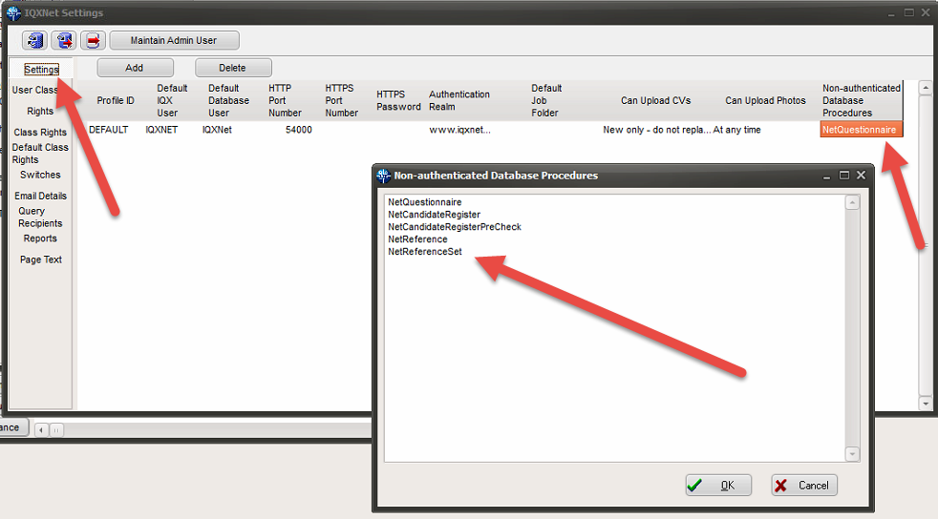
Whilst in IQXNet Settings set up access rights and other settings.

Switchable Views Setup
Under Maintenance > General Settings
Type in “Name or Notes”: On-Line, you should see this:

Setting up Branding
- Set up the brand using

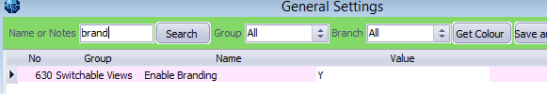
- In Agency Setup, locate the branding view, under ‘Vacancy Role’
- Select the branding function, and press open
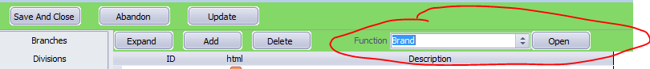

And set up the function as below

(
in persid char(20),in vacid char(20),in ClientOrTemp char(1),in Use char(20) )
returns char(20)
begin
declare RVal char(20);
if Use = 'WEBREFERENCE' then
set rval = 'WEBREFERENCE'
end if;
return RVal
end

- Back to branding, create a new brand called ‘WEB REFERENCE’
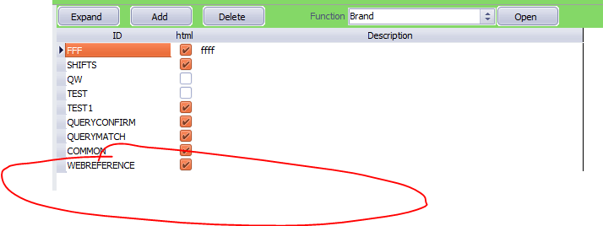
- Double click webreference, and create a new template
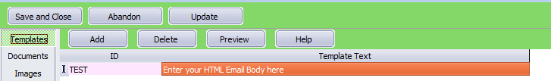
- You need to assign a template to ‘WEB REFERENCE’, this can be done by selecting
Once open, set up the function as below and save
(
in "BehaviourID" char(1),in "BrndID" char(20),in "EventID" char(1),in "TargetType" char(1),in "ShiftsID" char(1000),in "PlacementID" char(20) )
returns long varchar
begin
-- TargetType C or T (client/temp)
-- behaviourid P, S, E (Post, SMS or Email)
-- EventID C, X or O (Confirmation, Cancellation or Offer)
declare "RVal" long varchar;
declare "ID" char(20);
select "visibleid" into "ID" from "EN_brand" where "brandid" = "BrndID";
if("ID" = 'WEBREFERENCE') and("eventid" = 'D') then
select "brandtext" into "RVAL" from "en_template" where "brandid" = "BrndID" and "visibleid" = 'REQUEST';
return "RVAL"
end if;
if("ID" = 'WEBREFERENCE') and("eventid" = 'S') then
select "brandtext" into "RVAL" from "en_template" where "brandid" = "BrndID" and "visibleid" = 'SUMMARY';
return "RVAL"
end if;
return "RVAL"
end
- Xml jobs for sending out reference requests and a summary of the reference to referees will use the above SQL to pull in the standard web signature,
- Use the standard html wrap
- Convert the brand email body using boiler plate text
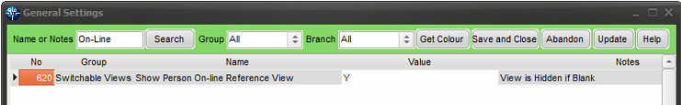
Make sure ‘Y’ is in the box for the Web Reference to show.
Refer to the IQX Web Referencing User Guide for information on using Web Referencing.

Reference Questionnaire Setup
The questionnaire must be set up via Maintenance – Agency Setup – Department – Select a department – Click Publish to Web – Reference Questionnaire.
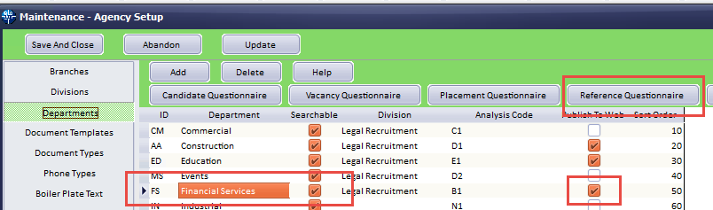
The next window will allow the creation of questions relevant to the Department. Web Publish and Web View must be clicked for this feature to be displayed on the Web. The long description is the question that will be displayed in the reference request.
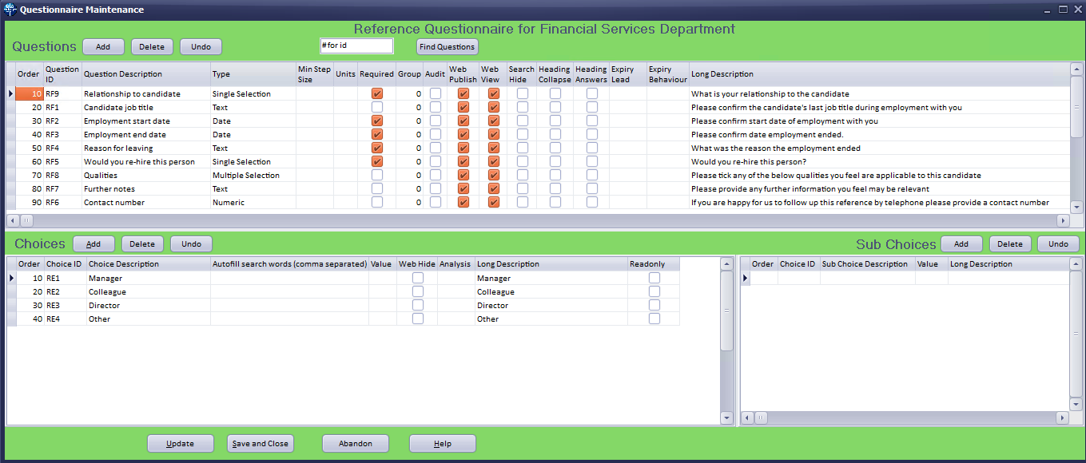
Each department will need separate Reference Questionnaires set up.

Job Runner Scheduling
To set up the automatic jobs for emailing the reference request and a summary of their completed reference to the referee got to Maintenance – Database setup.
In Job Runner Schedule Groups create a group for web referencing along with the default directory address housing the two xml jobs.
Send Web Reference Emails.xml and
Send Web Reference Summary.xml.
SMTP needs to be set up for this function to work.
The xml code for these are included at the end of this document.
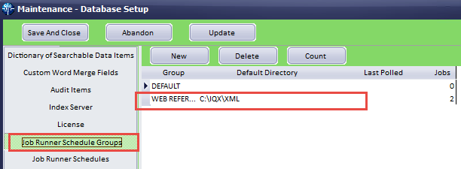
In Job Runner Schedules schedule the two xml jobs. Here you can detail how frequent these jobs will run. Note – Active means the jobs will be run as and when they are required.
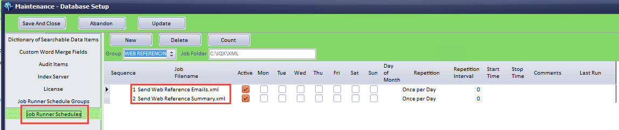
For testing each job can be run manually via Maintenance – Run a Job and locating the respective xml jobs.

Web Reference – Sending out the reference requests
All the web reference requests are stored in the database marked as ready to be emailed out.
The job below is then scheduled to run every night or at intervals set by the system administrator. It finds all the reference requests that need to be processed, creates an email for each request and then emails it out to the referee with a unique URL so that the referee can access an online form to fill in.

Reference Request Job - Send Web Reference Emails.xml

NOTE some lines (in bold) need to be populated by the System Administrator.

<?xml version="1.0"?>
<Job title="Email Reference Requests" autoclose="yes" dateformat="dd/mm/yyyy" delimiter="," stringquote="&#34;">
<Library>
<SetEmailBody smb_text="" smb_wrap="">
<SetVariable name="Emailbodytext" type="S" value="{smb_text}" />
<If x1="{emailhtml}" x2="Yes">
<SetVariable name="EmailBodyText" type="S" sql="select replace(:smb_text, char(13)+char(10), '&lt;BR/&gt;')" />
<SetVariable name="EmailBodyText" type="S" sql="select replace(:smb_wrap, '{{bodytext}', :EmailBodyText)" />
<SetVariable name="EmailBodyText" type="S" sql="select replace(:EmailBodyText, '{{signature}', :mysignature) " />
<SetVariable name="EmailBodyText" type="S" sql="select replace(:EmailBodyText, '{{origmessage}', '')" />
</If>
</SetEmailBody>
<GetBoilerPlateText gbt_text="" gbp_person="" gbp_vacancy="" gbp_company="" gbp_placement="" gbp_employment="" gbp_brand="">
<SetVariable name="BPText" value="" />
<StaticFunction service="CONVERT_BOILERPLATETEXT" person="{gbp_person}" company="gbp_company" employment="{gbp_employment}" placement="{gbp_placement}" vacancy="{gbp_vacancy}" brand="{gbp_brand}" text="{gbt_text}" />
<SetVariable name="BPText" type="S"><![CDATA[{WebServiceResult}]]></SetVariable>
</GetBoilerPlateText>
<DoBranding br_person="" br_vacancy="" br_use="" br_type="">
<!-- locate your brand based on a new notify status-->
<SetVariable name="brandid" sql="select BrandID from en_Brand where VisibleID = GetBrand(:br_person, :br_vacancy,:br_type, :br_use)" />
<!-- work out the template -->
<SetVariable name="emailbody" sql="select GetNotifyDocuments(:br_type, :brandid, 'D','','','')" />
<SetVariable name="emailbody" sql="select replace(:emailbody, '{{REFEREEADDRESSNAME}', :REFEREEADDRESSNAME)"/>
<SetVariable name="emailbody" sql="select replace(:emailbody, '{{yourURL}', :yourURL)"/>
<SetVariable name="emailbody" sql="select replace(:emailbody, '{{URLRequestCode}', :URLRequestCode)"/>
<!-- convert the body-->
<Call gbt_text="{emailbody}" gbp_person="{br_person}" gbp_vacancy="{br_vacancy}" gbp_brand="{brandid}">GetBoilerPlateText</Call>
<!-- slot body, default signature into html wrap-->
<Call smb_text="{BPText}" smb_wrap="{shtmlwrap}">SetEmailBody</Call>
<!-- <messagedialog>{EmailBodyText}</messagedialog>-->
</DoBranding>
</Library>
<SetVariable type="S" name="CRLF" sql="select string(char(13),char(10))"/>
<SetVariable type="S" name="TAB" sql="select string(char(9))"/>
<SetVariable type="S" name="SMTPHost" value="INSERT SMTP SERVER" />
<SetVariable type="S" name="SMTPPort" value="INSERT PORT VALUE" />
<SetVariable type="S" name="SMTPTLS" value= "YES OR NO" />
<SetVariable type="S" name="SMTPUserID" value="INSERT SMTP USER ID" />
<SetVariable type="S" name="SMTPPassword" value="INSERT SMTP PASSWORD" />
<SetVariable type="S" name="setBrand" value="INSERT BRAND" />
<SetVariable type="S" name="yourURL" value="INSERT URL" />
<ChangeDirectory path="{TempDir}"/>
<SQLExec ignoreerror="YES">drop table zzzIQXREF_TEMP_Refs</SQLExec>
<SQLExec>DECLARE LOCAL TEMPORARY TABLE zzzIQXREF_TEMP_Refs (
ReferenceRequestID char(20),
Email char(250))
on commit preserve rows;
</SQLExec>
<!-- Get default signature -->
<StaticFunction service="GetEmailSignature"/>
<SetVariable name="mysignature" type="S"><![CDATA[{WebServiceResult}]]></SetVariable>
<!-- get htmlwrap -->
<SetVariable name="emailhtml" type="S" value="Yes"/>
<SetVariable name="shtmlwrap" type="S" sql="select signature from emailsignature where emailsignatureid='HTML_WRAP'"/>
<IfSQL condition="'shtmlwrap'=''">
<SetVariable name="emailhtml" type="S" value="No"/>
</IfSQL>
<SQLExec><![CDATA[
insert into zzzIQXREF_TEMP_Refs
SELECT
ReferenceRequestID, replace(trim(Email), ' ', '') as TrimEmail
FROM "pears"."ReferenceRequest"
where whensent is null and whencompleted is null and whenprocessed is null and
TrimEmail like '%@%.%' and
TrimEmail not like '% %' and TrimEmail not like '%..%' and TrimEmail not like '%.@%' and TrimEmail not like '.%' and TrimEmail not like '%.' and TrimEmail not like '%@%@%'
]]>
</SQLExec>
<SQLQuery>
<SQLSelect><![CDATA[
select ReferenceRequest.ReferenceRequestID, person.name as PersonName, RefereeAddressName, RefereePosition, ReferenceRequest.CompanyName as RefereeCompanyName, z.Email as RefereeEmail, ReferenceRequest.URLRequestCode,
staff.email as SMTPSender, staff."name" as Staffname, person.personid as pid
FROM ReferenceRequest
inner join staff on staff.staffid=ReferenceRequest.staffid
inner join person on person.personid = ReferenceRequest.personid
inner join department on department.departmentid=ReferenceRequest.departmentid
inner join zzzIQXREF_TEMP_Refs z on (z.ReferenceRequestID = ReferenceRequest.ReferenceRequestID)
order by ReferenceRequest.WhenCreated
]]>
</SQLSelect>
<IfAnyRows>
<ForEachRow>
<Block>
<Call br_person="{pid}" br_use="WEBREFERENCE">DoBranding</Call>
<SendEmail subject="{Brand} Reference Request" smtpport="{SMTPPort}" smtptls="{SMTPTLS}" smtphost="{SMTPHost}" smtpuserid="{SMTPUserID}" html="YES" smtpsender="{SMTPSender}" smtppassword="{SMTPPassword}">
<EmailRecipients>
<WriteLn>{RefereeEmail}</WriteLn>
</EmailRecipients>
<EmailBody>{EmailBodyText}</EmailBody>
<EmailPlainBody>
<WriteLn><![CDATA[{EmailBodyText}]]></WriteLn>
</EmailPlainBody>
</SendEmail>
<SetVariable name="emailFailed" value=""/>
</Block>
<Catch>
<SetVariable name="emailFailed" value="{Exception}"/>
</Catch>
<IfSQL condition="'{emailFailed}' = ''">
<SQLExec>
update ReferenceRequest
set WhenSent = current timestamp
from zzzIQXREF_TEMP_Refs
where ReferenceRequest.ReferenceRequestID = zzzIQXREF_TEMP_Refs.ReferenceRequestID
</SQLExec>
</IfSQL>
</ForEachRow>
</IfAnyRows>
</SQLQuery>
<SQLExec ignoreerror="YES">drop table zzzIQXREF_TEMP_Refs</SQLExec>
</Job>
The URL is unique to each reference request. The URL also expires in 7 day. There are no edit or delete features on the form. If there are any errors, the consultant will have to generate a new reference request.
The email text that is being sent out is standard for all requests. There is no functionality for the text of the email to be dynamic.

The Summary – Send Web Reference Summary.xml.

NOTE some lines (in bold) need to be populated by the System Administrator.

<?xml version="1.0"?>
<Job title="Email Reference Requests Summary" autoclose="yes" dateformat="dd/mm/yyyy" delimiter="," stringquote="&#34;">
<Library>
<SetEmailBody smb_text="" smb_wrap="">
<SetVariable name="Emailbodytext" type="S" value="{smb_text}" />
<If x1="{emailhtml}" x2="Yes">
<SetVariable name="EmailBodyText" type="S" sql="select replace(:smb_text, char(13)+char(10), '&lt;BR/&gt;')" />
<SetVariable name="EmailBodyText" type="S" sql="select replace(:smb_wrap, '{{bodytext}', :EmailBodyText)" />
<SetVariable name="EmailBodyText" type="S" sql="select replace(:EmailBodyText, '{{signature}', :mysignature) " />
<SetVariable name="EmailBodyText" type="S" sql="select replace(:EmailBodyText, '{{origmessage}', '')" />
</If>
</SetEmailBody>
<GetBoilerPlateText gbt_text="" gbp_person="" gbp_vacancy="" gbp_company="" gbp_placement="" gbp_employment="" gbp_brand="">
<SetVariable name="BPText" value="" />
<StaticFunction service="CONVERT_BOILERPLATETEXT" person="{gbp_person}" company="gbp_company" employment="{gbp_employment}" placement="{gbp_placement}" vacancy="{gbp_vacancy}" brand="{gbp_brand}" text="{gbt_text}" />
<SetVariable name="BPText" type="S"><![CDATA[{WebServiceResult}]]></SetVariable>
</GetBoilerPlateText>
<DoBranding br_person="" br_vacancy="" br_use="" br_type="">
<!-- locate your brand based on a new notify status -->
<SetVariable name="brandid" sql="select BrandID from en_Brand where VisibleID = GetBrand(:br_person, :br_vacancy,:br_type, :br_use)" />
<!-- work out the template -->
<SetVariable name="emailbody" sql="select GetNotifyDocuments(:br_type, :brandid, 'S','','','')" />
<SetVariable name="emailbody" sql="select replace(:emailbody, '{{JOB_Email_Question_and_Answers}', :Email_Question_and_Answers)"/>
<SetVariable name="emailbody" sql="select replace(:emailbody, '{{JOB_RefereeAddressName}', :RefereeAddressName)"/>
<!-- convert the body -->
<Call gbt_text="{emailbody}" gbp_person="{br_person}" gbp_vacancy="{br_vacancy}" gbp_brand="{brandid}">GetBoilerPlateText</Call>
<!-- slot body, default signature into html wrap-->
<Call smb_text="{BPText}" smb_wrap="{shtmlwrap}">SetEmailBody</Call>
<!-- <messagedialog>{EmailBodyText}</messagedialog>-->
</DoBranding>
</Library>
<SetVariable type="S" name="CRLF" sql="select string(char(13),char(10))"/>
<SetVariable type="S" name="TAB" sql="select string(char(9))"/>
<SetVariable type="S" name="SMTPHost" value="INSERT SMTP SERVER" />
<SetVariable type="S" name="SMTPPort" value="INSERT PORT VALUE" />
<SetVariable type="S" name="SMTPTLS" value= "YES OR NO" />
<SetVariable type="S" name="SMTPUserID" value="INSERT SMTP USER ID" />
<SetVariable type="S" name="SMTPPassword" value="INSERT SMTP PASSWORD" />
<SetVariable type="S" name="setBrand" value="INSERT BRAND" />
<SetVariable type="S" name="yourURL" value="INSERT URL" />
<ChangeDirectory path="{TempDir}"/>
<!-- Get default signature -->
<StaticFunction service="GetEmailSignature"/>
<SetVariable name="mysignature" type="S"><![CDATA[{WebServiceResult}]]></SetVariable>
<!-- get htmlwrap -->
<SetVariable name="emailhtml" type="S" value="Yes"/>
<SetVariable name="shtmlwrap" type="S" sql="select signature from emailsignature where emailsignatureid='HTML_WRAP'"/>
<IfSQL condition="'shtmlwrap'=''">
<SetVariable name="emailhtml" type="S" value="No"/>
</IfSQL>
<SQLQuery>
<Message>Fetching all completed references</Message>
<SQLSelect><![CDATA[
select ReferenceRequest.DepartmentID, ReferenceRequest.ReferenceRequestID, ReferenceRequest.Email, ReferenceRequest.RefereeAddressName, staff.name as Staffname, person.name as PersonName, person.personid as pid
FROM ReferenceRequest
Join staff on ReferenceRequest.StaffID = staff.staffid
Join person on ReferenceRequest.PersonID = person.personid
WHERE ReferenceRequest.ReferenceConfirmationRequired = 1 AND ReferenceRequest.WhenCompleted is not null
order by ReferenceRequest.WhenCreated
]]>
</SQLSelect>
<IfAnyRows>
<ForEachRow> <!-- for each reference request -->
<Message>Fetching {PersonName}'s answers</Message>
<SetVariable type="S" name="Email_Question_and_Answers" value=""/>
<SQLQuery>
<SQLSelect><![CDATA[
SELECT isnull( t.LongDescription, t.description) as question,
(if t.tagtype= 'D' THEN dateformat(getquestdate(string('R',:DepartmentID),t.tagid,:ReferenceRequestID),'dd/mm/yyyy')
else getquestanswer(string('R',:DepartmentID),t.tagid,:ReferenceRequestID) endif) as answer
FROM tag t
WHERE t.taglocation = 'R{DepartmentID}' order by t.sortorder
]]>
</SQLSelect>
<IfAnyRows>
<ForEachRow> <!-- for each question + answer -->
<SetVariable type="S" name="Email_Question_and_Answers" value="
{Email_Question_and_Answers}
&lt;tr&gt;
&lt;td&gt; &lt;strong&gt;{question}&lt;/strong&gt; &lt;/td&gt;
&lt;td&gt;{answer}&lt;/td&gt;
&lt;/tr&gt;
" />
</ForEachRow>
</IfAnyRows>
</SQLQuery>
<Call br_person="{pid}" br_use="WEBREFERENCE">DoBranding</Call>
<Block>
<Message>Sending Email to {RefereeAddressName} / {Email}</Message>
<SendEmail subject="{Brand} Reference Summary" smtpport="{SMTPPort}" smtptls="{SMTPTLS}" smtphost="{SMTPHost}" smtpuserid="{SMTPUserID}" html="YES" smtpsender="{SMTPSender}" smtppassword="{SMTPPassword}">
<EmailRecipients>
<WriteLn>{Email}</WriteLn>
</EmailRecipients>
<EmailBody>{EmailBodyText}</EmailBody>
<EmailPlainBody>
<WriteLn><![CDATA[{EmailBodyText}]]></WriteLn>
</EmailPlainBody>
</SendEmail>
<SetVariable name="emailFailed" value=""/>
<Message>Updating Table</Message>
<SQLExec><![CDATA[UPDATE ReferenceRequest SET ReferenceConfirmationRequired = 0 WHERE ReferenceRequestID = '{ReferenceRequestID}']]></SQLExec>
</Block>
<Catch>
<SetVariable name="emailFailed" value="{Exception}"/>
</Catch>
</ForEachRow>
</IfAnyRows>
</SQLQuery>
</Job>

